**User guide**

This guide is meant for the user of this system. To help them navigate through the interfaces and successfully complete their intended actions.

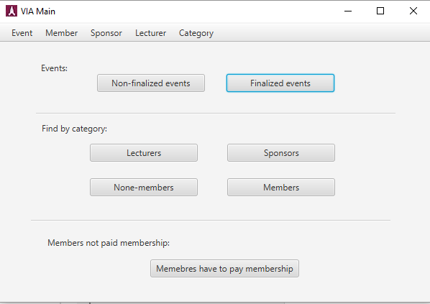

This is the main frame for VIA. Here it is shown a menu bar that is located in the top horizontal part of the main window. Below the menu bar there are multiple buttons for multiple actions.

From this window it is possible to access every necessary action the user choses to initiate.

**Using the menu bar**



From the menu bar it is possible to access “Event”, “Member”, ”Sponsor”, ”Lecturer” and ”Category”. Clicking on any of these menu bar elements, a drop down list of menu items will appear.

**Using the menu items (Event)**

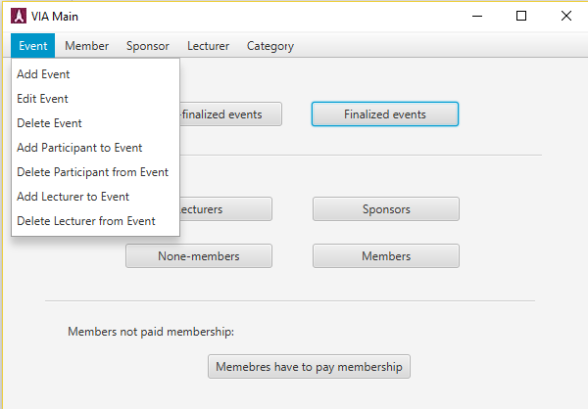

Clicking on the menu item element named “Event” it is possible to Add, edit and delete a event. In addition it is possible to add participants and lecturers to certain events and delete them.

**Add Event**

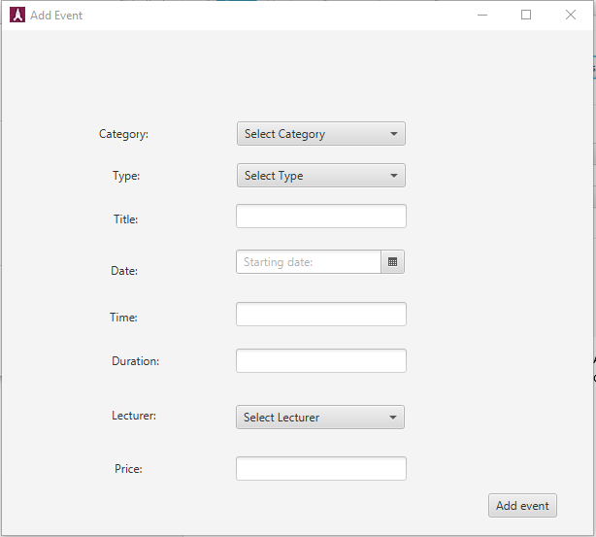

The menu item “Add Event” is meant to create events.

Next to items (i.e. Category, Type, Title, etc.) there are fields that need to be completed in order to create an event. If one of these fields is not completed it is still possible to create an event but it will be categorized as a, ”Non-Finalized event”.

**Edit Event**

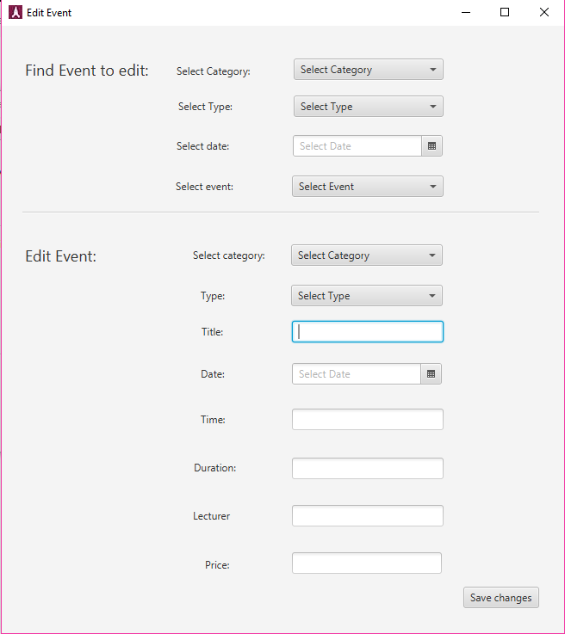

The menu item “Edit Event” is meant to edit events.

In this section the user can find the respective event they wish to edit.

At the top half of the interface it is possible to search for an existing event. When the Event is chosen, all of its corresponding information will be showed in the “Edit Event” section of this interface. From there it is possible to add missing information and to finalize the event. When all of the needed changes are made then it is necessary to press the button “Save changes” to store the changes in the system file for future use.

**Delete Event**

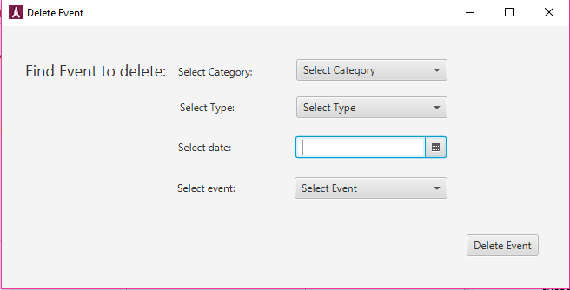

In this interface it is possible to delete an existing event.

First the user has to match the corresponding information regarding to the event in mind. When the event is found the user has to select it form the combo box and press the button “Delete” to delete the event.

**Add participant** (same steps as for Add lecturer to event)

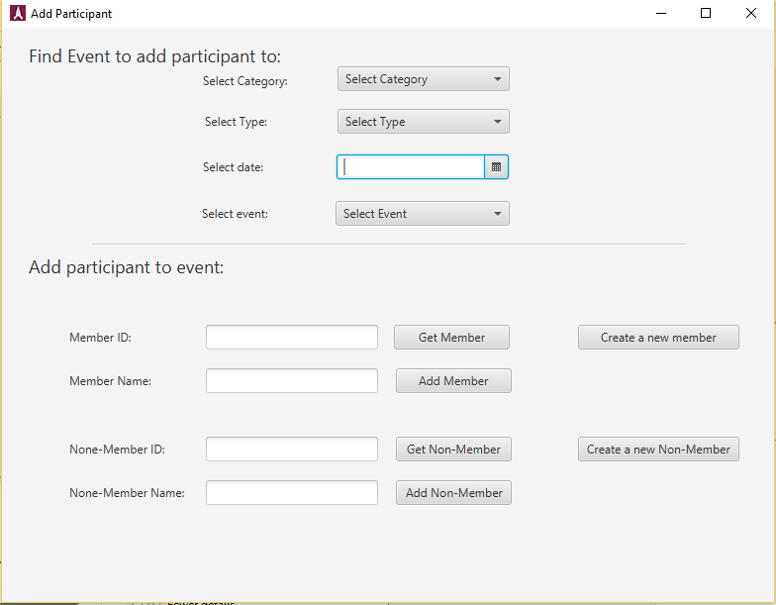

This interface is meant to add a participant to an existing event.

First the user has to fill out the necessary search criteria and select the event from the combo box. After the event is selected the user can start to add participants to the event.

The lower part of the interface is meant to add participants to the chosen event. To add a participant to an event the user first has to input the ID of the participant it wishes to add. After the user has entered the ID, the next step is to press the button “Get member”, after that the members name will be displayed in the text field below and the by pressing the button “Add member” the participant will be added to the event.

**Delete Participant** (same steps as for Delete lecturers from event)

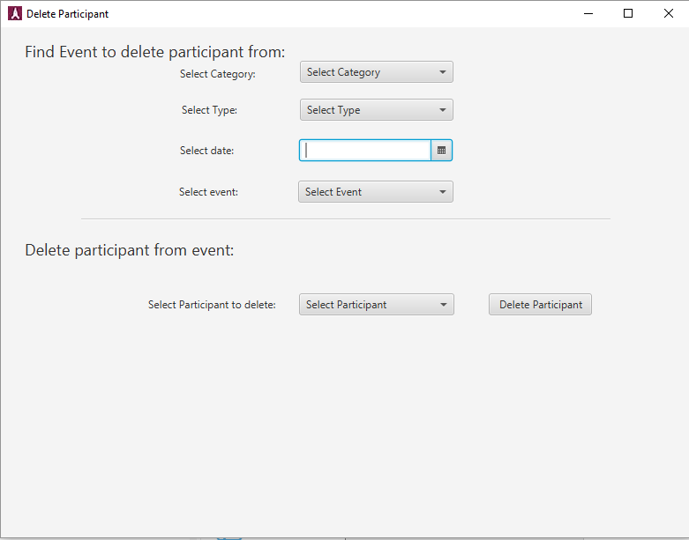

In this interface it is possible to delete a participant from a certain event.

By filling out the fields at the top part of the interface the user select the event from which to delete a participant from.

When the event is chosen the next step is to select the participant from the event. After the participant is selected the user has to press the button “Delete Participant” to remove the participant from the event.

**Add a member** (Same steps for “Add sponsor” and “Add lecturer”)

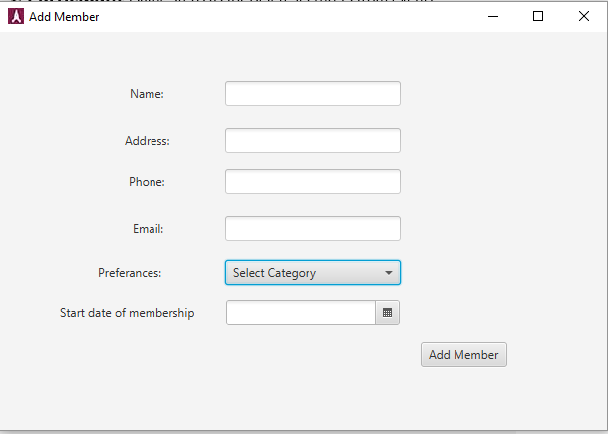

In this interface it is possible to add a member to the systems.

The user has to fill out all of the required fields in order to create a new member. When all of the fields are filled out the next step is to press the button “Add member” to add the newly created member to the system.

**Edit a Member** (Same steps as for the “Edit sponsor” and “Edit Lecturer”)

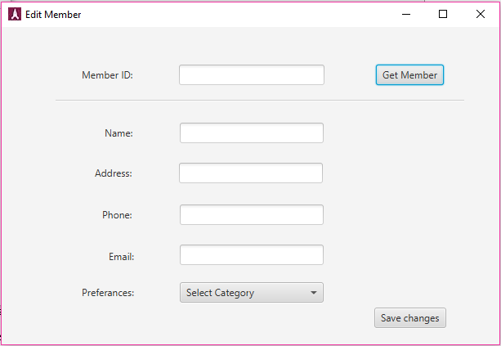

In this interface it is possible to edit information regarding to a particular member.

First the user has to find the member it wishes to edit. In the text field next to “Member ID” the user has to input the corresponding members ID. After that the button “Get member” has to be pressed in order to find the member in question.

After the member is found, all of the required text field will be filled out with information regarding the member and after that the user can change all of the necessary information. After the changes are made the user has to press the button “Save changes” in order to save all of the edited information to the system.

**Delete Member** (Same steps as for “Delete sponsor” and “delete lecturer”)

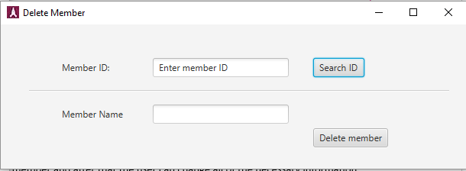

In this interface the user can delete a member from the system.

First the user has to input the ID of the member it wishes to delete. After entering the ID, the user has to press the button “Search ID” to find the member in question.

After the member has been found the user the presses the button “Delete member” to remove the member for the system.

**Manage Category**

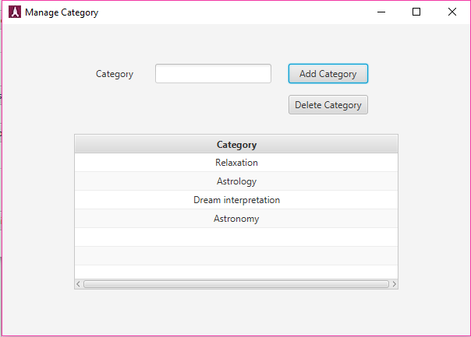

In this interface it is possible for the user to add/delete a category to/from the system.

The user has to enter the title of the category and the press either the button “Add category” or “Delete category”.

**Find none-finalized events**

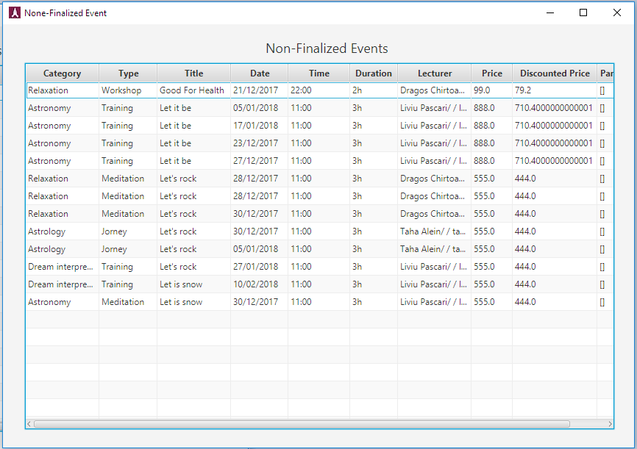

When press on “None-finalized Event” button in main window, the none-finalized events window, will appear, this window all none finalized events will appear one by one, there is a possibility to sort the column, when press on column head.

**Find Finalized events**

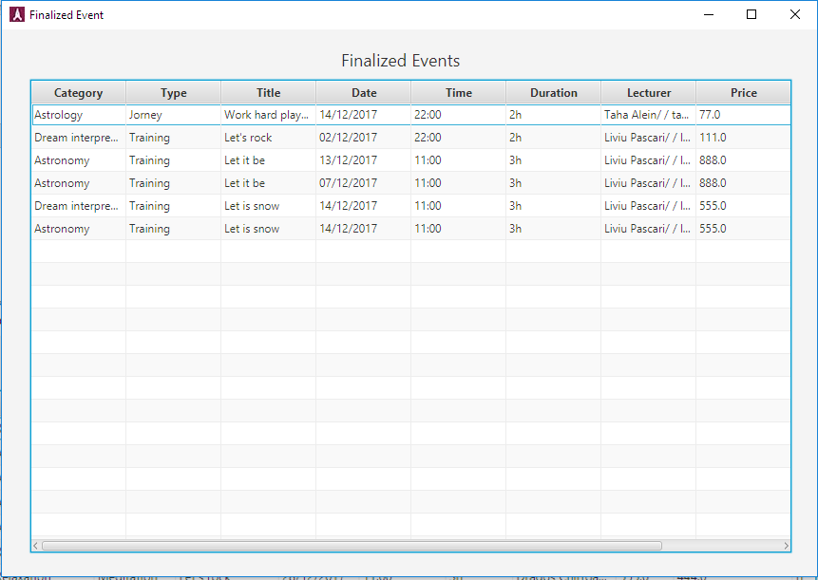

When press on “finalized Event” button in main window, the finalized events window, will appear, this window all finalized events will appear one by one, there is a possibility to sort the column, when press on columns’ head.

**Find Lecturers by category**

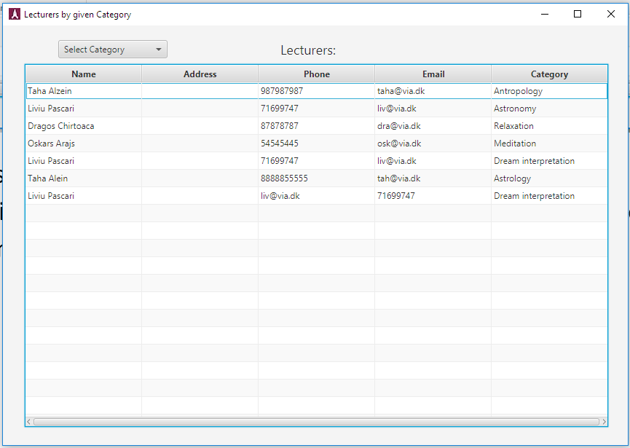

When press on “Lecturers” button in main window, the “lecturers by given category” window will appear, in this window all lecturers will appear one by one, by selecting a category from the “combobox” the lecturers for given category will be shown, otherwise, selecting “show all” will result to show them all again.

**Find Sponsor by category**

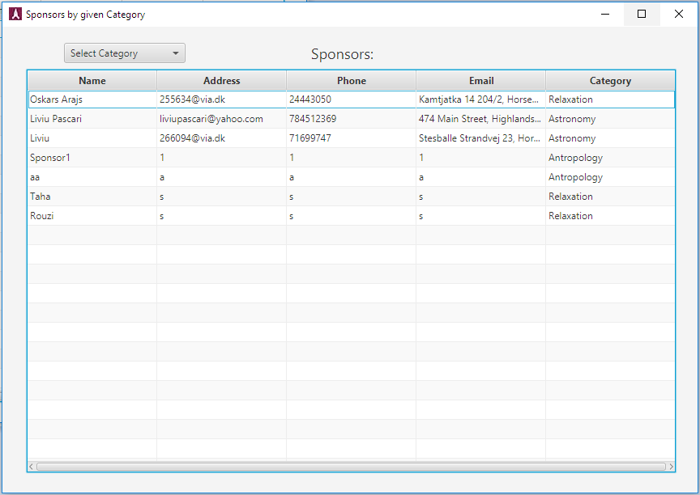

When press on “Sponsors” button in main window, the “Sponsors by given category” window will appear, in this window all Sponsors will appear one by one, by selecting a category from the “combobox” the Sponsors for given category will be shown, otherwise, selecting “show all” will result to show them all again.

**Find None-Members by category**

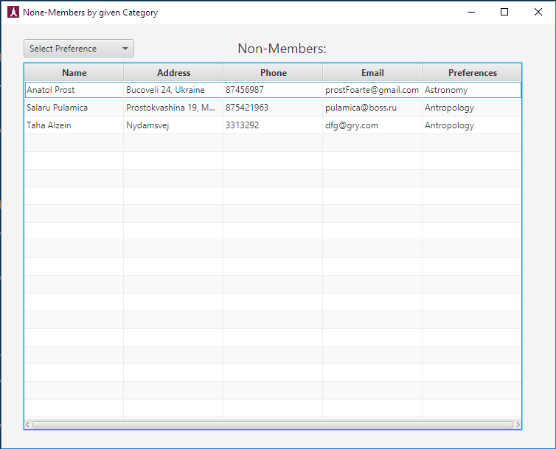

When press on “None-Members” button in main window, the “None-Members by given category” window will appear, in this window all None-Members will appear one by one, by selecting a preference from the “combobox” the None-Members for given preference will be shown, otherwise, selecting “show all” will result to show them all again.

**Find Members by category**

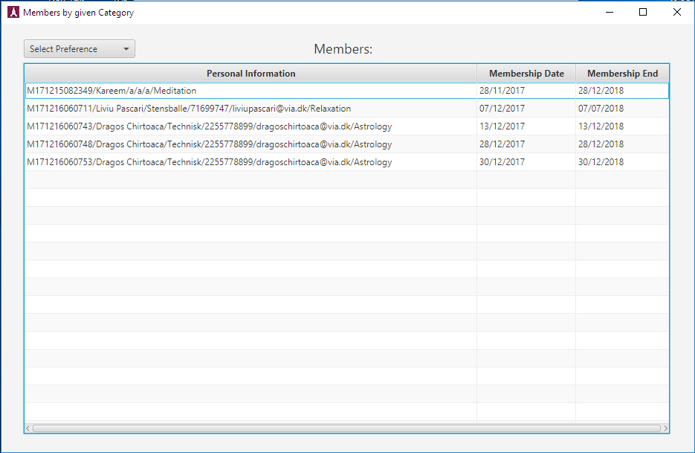

When press on “Members” button in main window, the “Members by given category” window will appear, in this window all Members will appear one by one, by selecting a preference from the “combobox” the Members for given preference will be shown, otherwise, selecting “show all” will result to show them all again.

**Find Members have to pay membership**

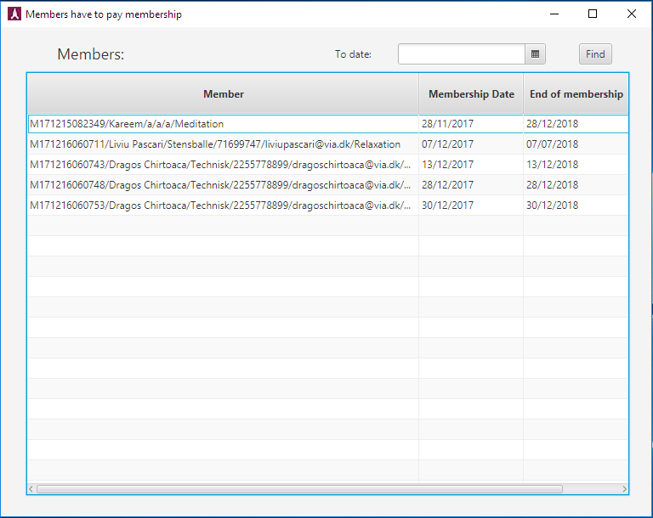

When press on “Members have to pay membership” button in main window, the “Members have to pay membership” window will appear, in this window all Members will appear one by one, there is a possibility to find them by date of ending membership.